Homework 01

PB20000296 郑滕飞

**2.1.a**

字母：abcdefghijklmnopqrstuvwxyzABCDEFGHIJKLMNOPQRSTUVWXYZ

数字：0123456789

符号：! " # % & ' () * + , －. / :; < = > ? [ \ ] ^ _ { | } ~

空白符：空格、水平制表符\t、垂直制表符\v、换行\n、换页\f

不可打印字符：字符串终止\0、警报符\a、退格\b、回车\r

**2.3.b**

由于0与1都为0?1*可表示的句子，原式即可看作(0|1)*，可以表示任何由01组成的字符串(含空串)。

**2.4.b**

A*a*B*b*C*c*D*d*E*e*F*f*G*g*H*h*I*i*J*j*K*k*L*l*M*m*N*n*O*o*P*p*Q*q*R*r*S*s*T*t*U*u*V*v*W*w*X*x*Y*y*Z*z*

**2.4.i**

b*(ab­+)*a?

**2.7.c**

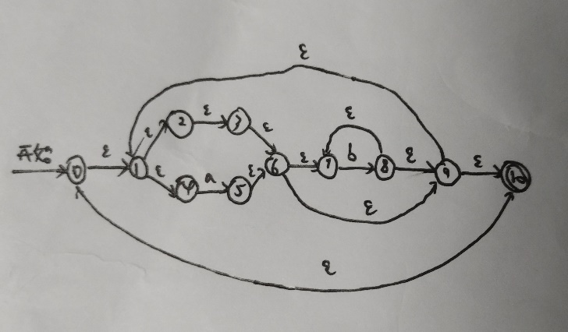

0-1-4-5-6-7-8-9-1-4-5-6-7-8-7-8-9-1-4-5-6-7-8-9-10

**2.12.a**

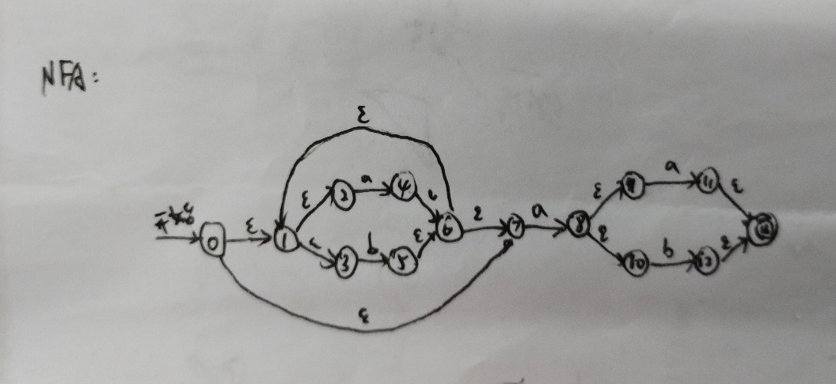

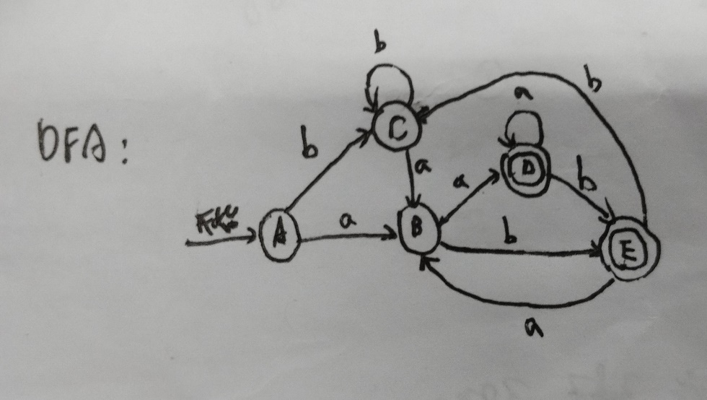

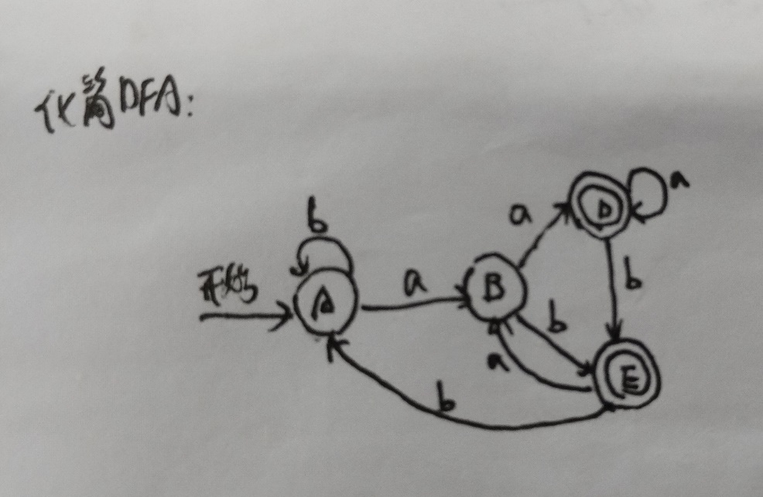

Homework 02

PB20000296 郑滕飞

**3.1.a**

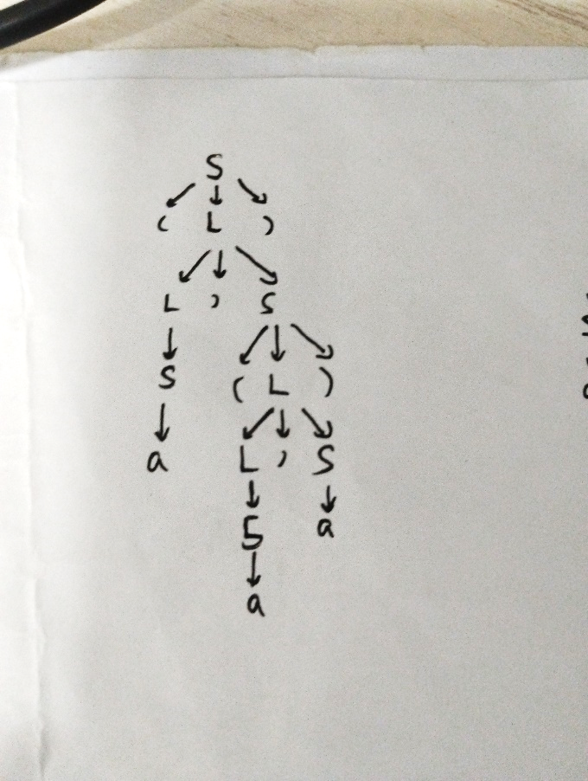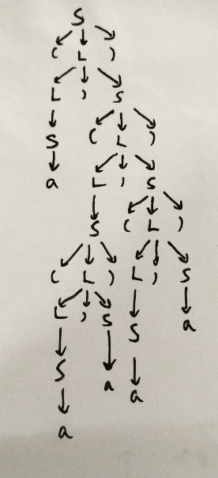

**3.1.c**

S => (L) => (L,S) => (L,(L)) => (L,(L,S)) => (L,(L,a)) => (L,(S,a))

=> (L,(S,a)) => (L,(a,a)) => (S,(a,a)) => (a,(a,a))

S => (L) => (L,S) => (L,(L)) => (L,(L,S)) => (L,(L,a)) => (L,(S,a))

=> (L,(S,a)) => (L,(a,a)) => (S,(a,a)) => ((L),(a,a))

=> ((L,S),(a,a)) => ((L,a),(a,a)) => ((S,a),(a,a)) => ((a,a),(a,a))

**3.2.a**

S => aSbS => abSaSbS => abaSbS => ababS => abab

S => aSbS => abS => abaSbS => ababS => abab

**3.3**

S -> S and T | T

T -> T or U | U

U -> not U | true | false | (S)

Homework 03

PB20000296 郑滕飞

**3.17**

(每个状态都可作为终止状态)

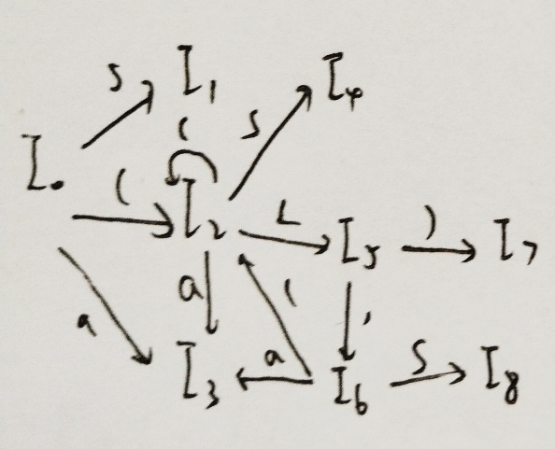

**3.19.a**

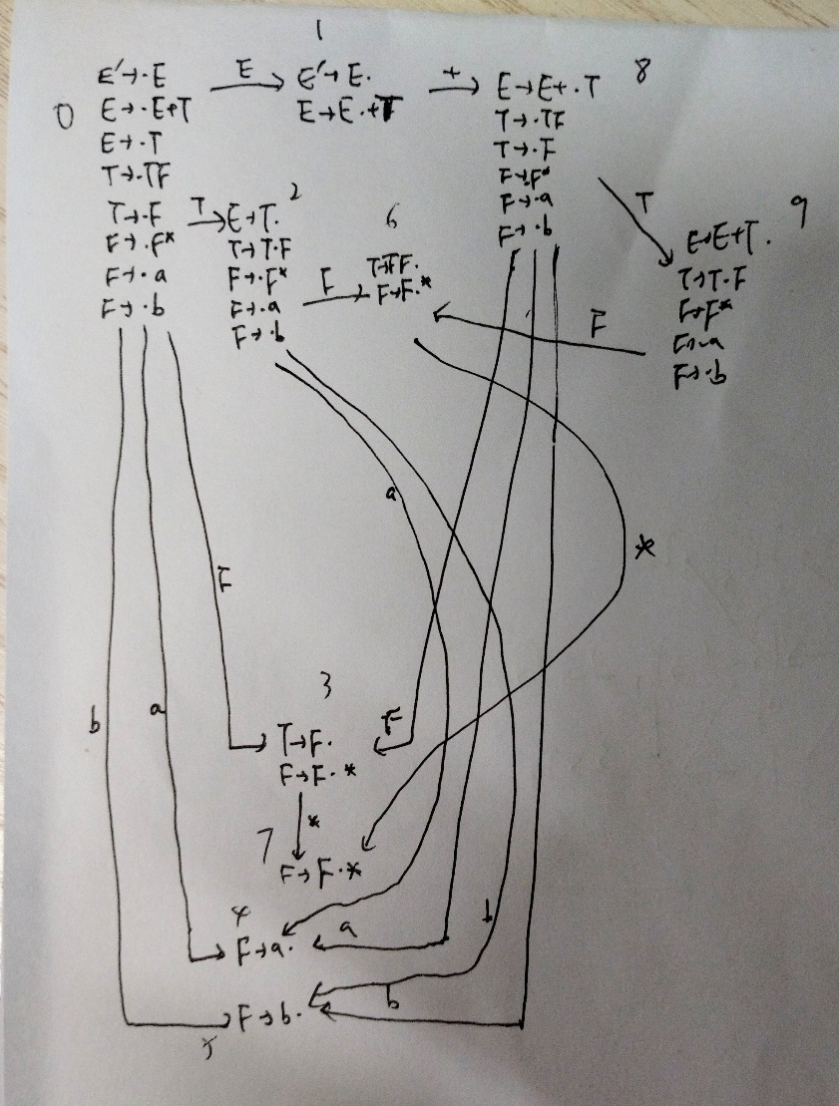

**1** E->E+T **2** E->T **3** T->TF **4** T->F

**5** F->F* **6** F->a **7** F->b

|  |  |  |  |  |  |  |  |  |
| --- | --- | --- | --- | --- | --- | --- | --- | --- |
| **状态** | **a** | **b** | **\*** | **+** | **$** | **E** | **T** | **F** |
| **0** | s4 | s5 |  |  |  | 1 | 2 | 3 |
| **1** |  |  |  | s8 | acc |  |  |  |
| **2** | s4 | s5 |  | r2 | r2 |  |  | 6 |
| **3** | r4 | r4 | s7 | r4 | r4 |  |  |  |
| **4** | r6 | r6 | r6 | r6 | r6 |  |  |  |
| **5** | r7 | r7 | r7 | r7 | r7 |  |  |  |
| **6** | r3 | r3 | s7 | r3 | r3 |  |  |  |
| **7** | r5 | r5 | r5 | r5 | r5 |  |  |  |
| **8** | s4 | s5 |  |  |  |  | 9 | 3 |
| **9** | s4 | s5 |  | r1 | r1 |  |  | 6 |

**3.21.a**

是LL(1)：

FIRST(AaBb)={a} FIRST(BbBa)={b}

FIRST(A)={ε} FOLLOW(B)={a,b}

FIRST(B)={ε} FOLLOW(A)={a,b}

由此满足LL(1)。

不是SLR(1)：空串可能按A或B进行规约，无法确定。

Homework 04

PB20000296 郑滕飞

**3.4.b**

U -> U’|’T | T

T -> TS | S

S -> S* | R

R -> a | b | (U)

**3.10**

|  |  |  |  |  |  |
| --- | --- | --- | --- | --- | --- |
| **非终结符** | **输入符号** | | | | |
| **int** | **real** | **id** | **,** | **$** |
| D | D -> TL | D -> TL |  |  |  |
| T | T -> **int** | T -> **real** |  |  |  |
| L |  |  | L -> **id** R |  |  |
| R |  |  |  | R -> **, id** R | R -> **ε** |

**3.12**

FIRST(AB) ∩ FIRST(PQx) = {x}，从而不是。

**3.19.b**

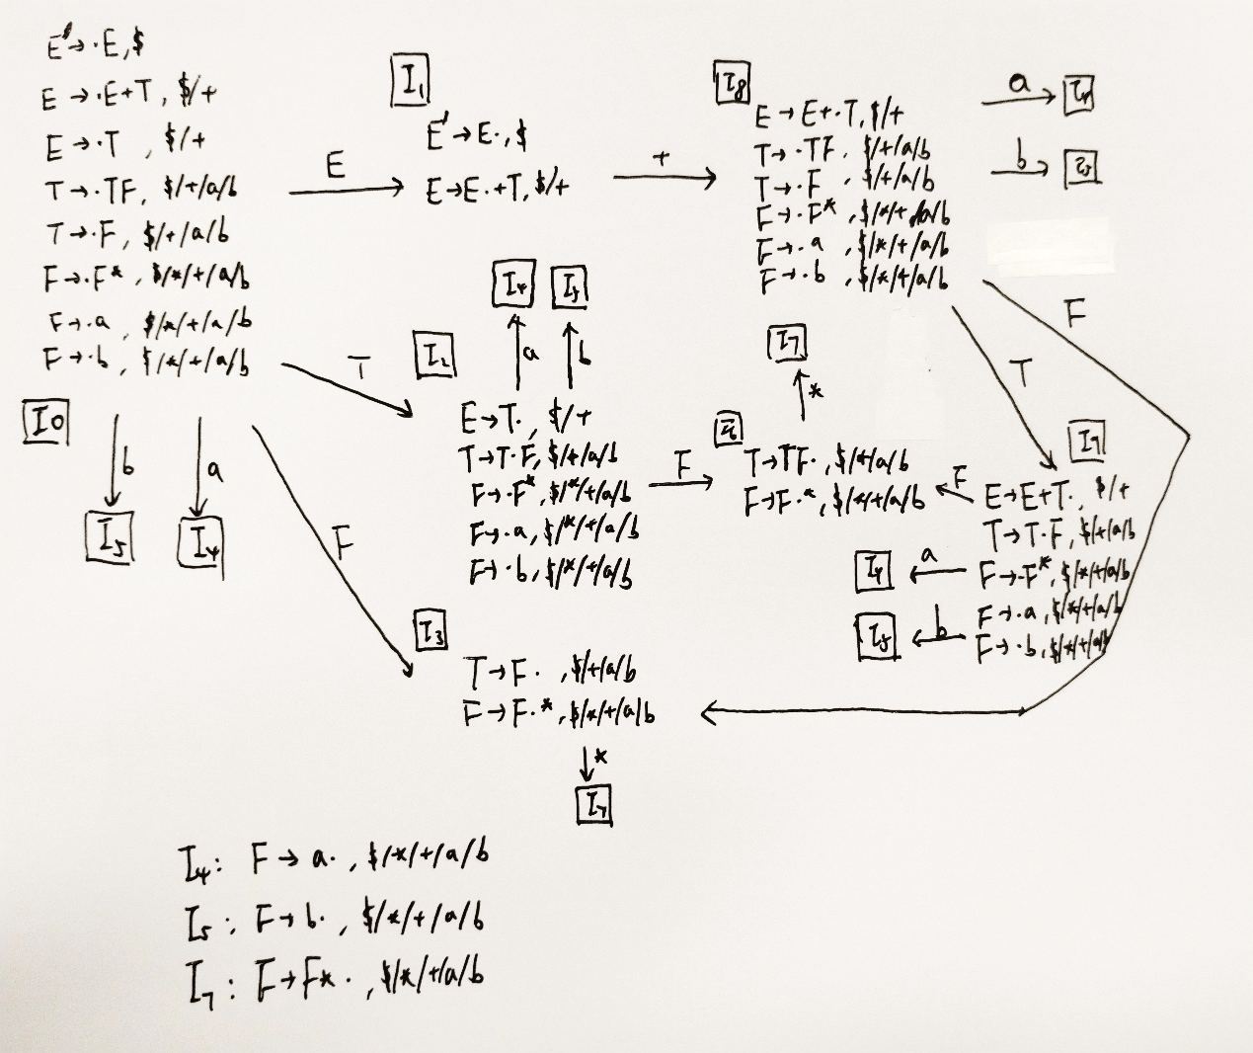

**1** E->E+T **2** E->T **3** T->TF **4** T->F

**5** F->F* **6** F->a **7** F->b

|  |  |  |  |  |  |  |  |  |
| --- | --- | --- | --- | --- | --- | --- | --- | --- |
| **状态** | **a** | **b** | **\*** | **+** | **$** | **E** | **T** | **F** |
| **0** | s4 | s5 |  |  |  | 1 | 2 | 3 |
| **1** |  |  |  | s8 | acc |  |  |  |
| **2** | s4 | s5 |  | r2 | r2 |  |  | 6 |
| **3** | r4 | r4 | s7 | r4 | r4 |  |  |  |
| **4** | r6 | r6 | r6 | r6 | r6 |  |  |  |
| **5** | r7 | r7 | r7 | r7 | r7 |  |  |  |
| **6** | r3 | r3 | s7 | r3 | r3 |  |  |  |
| **7** | r5 | r5 | r5 | r5 | r5 |  |  |  |
| **8** | s4 | s5 |  |  |  |  | 9 | 3 |
| **9** | s4 | s5 |  | r1 | r1 |  |  | 6 |

**3.27.b**

不是LR(1)。假设第一个字符为d，则该文法在最开始就需要决定移进d还是空规约出W(否则移进d后如果遇到p，由于只有W -> Wd，已经来不及在栈中规约出W)，但这是无法确定的。

Homework 05

PB20000296 郑滕飞

**4.3.a**

|  |  |
| --- | --- |
| **产生式** | **语义规则** |
| S’ -> S | print(S.val) |
| S -> (L) | S.num = L.num + 1 |
| S -> a | S.num = 0 |
| L -> L1, S | L.num = L1.num + S.num |
| L -> S | L.num = S.num |

**4.3.b**

|  |  |
| --- | --- |
| **产生式** | **语义规则** |
| S’ -> S | print(S.val) |
| S -> (L) | S.maxd = L.maxd + 1 |
| S -> a | S.maxd = 0 |
| L -> L1, S | L.maxd = max(L1.maxd, S.maxd) |
| L -> S | L.maxd = S.maxd |

**4.9.b**

*修改文法

|  |  |
| --- | --- |
| **产生式** | **语义规则** |
| S -> L.R | S.sum = L1.sum + L2.sum  L.pos = 0  R.pos = -1 |
| S -> L | S.sum = L.sum  L.pos = 0 |
| L -> L1B | L.sum = L1.sum + B.val  L1.pos = L.pos + 1  B.pos = L.pos |
| L -> B | L.sum = B.val  B.pos = L.pos |
| R -> BR1 | R.sum = R1.sum + B.val  R1.pos = R.pos – 1  B.pos = R.pos |
| R -> B | R.sum = B.val  B.pos = R.pos |
| B -> 0 | B.val = 0 |
| B -> 1 | B.val = pow(2, B.pos) |

**4.12.a**

|  |  |
| --- | --- |
| **产生式** | **语义规则** |
| B -> S | S.depth = 0 |
| S -> (L) | L.depth = S.depth + 1 |
| S -> a | print(S.depth) |
| L -> L1, S | S.depth = L1.depth = L.depth |
| L -> S | S.depth = L.depth |

B -> {S.depth = 0} S

S -> ( {L.depth = S.depth + 1} L)

S -> a {print(S.depth)}

L -> {L1.depth = L.depth} L1, {S.depth = L.depth} S

L -> {S.depth = L.depth} S

**4.12.b**

|  |  |
| --- | --- |
| **产生式** | **语义规则** |
| B -> S | S.pos = 1 |
| S -> (L) | S.len = L.len + 2  L.pos = S.pos + 1 |
| S -> a | S.len = 1  print(S.pos) |
| L -> L1, S | L.len = L1.len + S.len + 1  L1.pos = L.pos  S.pos = L1.len + L1.pos + 1 |
| L -> S | L.len = S.len  S.pos = L.pos |

B -> {S.pos = 1} S

S -> ( {L.pos = S.pos + 1} L) {S.len = L.len + 2}

S -> a {S.len = 1; print(S.pos)}

L -> {L1.pos = L.pos} L1,

{S.pos = L1.len + L1.pos + 1} S { L.len = L1.len + S.len + 1}

L -> {S.pos = L.pos} S {L.len = S.len}

Homework 06

PB20000296 郑滕飞

**7.1.d**

t1 = a + b

t2 = -t1

t3 = c + d

t4 = t2 * t3

t5 = a + b

t6 = t5 + c

t7 = t4 + t6

(t7为结果)

**7.2.c**

t1 = a

t2 = 0

goto JUDGE

JUDGE:

if t2 <= 10 goto COUNT

goto OUT

COUNT:

t1[t2] = 0

goto JUDGE

OUT:

return

**7.5**

P -> {D.offset = 0} D; S

D -> {D1.offset = D.offset} D1;

{D2.offset = D1.offset + D1.width} D2

{D.width = D1.width + D2.width}

D -> id:T {enter(id.lexeme), T.type, D.offset); D.width = T.width}

T -> integer {T.type = integer; T.width = 4}

T -> real {T.type = real; T.width = 8}

T -> array[num] of T1

{T.type = array(num.val, T1.type); T.width = num.val * T1.width}

T -> ^T1 {T.type = pointer(T1.type); T.width = 4}

Homework 07

PB20000296 郑滕飞

**9.3.a**

*此处数字代表对应的语句

|  |  |  |  |  |
| --- | --- | --- | --- | --- |
|  | gen | kill | IN | OUT |
| B1 | 1,2 | 8,10,11 |  | 1,2 |
| B2 | 3,4 | 5,6 | 1,2,3,4,5,8,9 | 1,2,3,4,8,9 |
| B3 | 5 | 4,6 | 1,2,3,4,6,7,8,9 | 1,2,3,5,7,8,9 |
| B4 | 6,7 | 4,5,9 | 1,2,3,5,7,8,9 | 1,2,3,6,7,8 |
| B5 | 8,9 | 2,7,11 | 1,2,3,4,5,7,8,9 | 1,3,4,5,8,9 |
| B6 | 10,11 | 1,2,8 | 1,3,4,5,8,9 | 3,4,5,9,10,11 |

**9.3.b**

*U = {1, 2, a+b, c-a, b+d, e+1, b*d, a-d}，按序编号为A到H

|  |  |  |  |  |
| --- | --- | --- | --- | --- |
|  | e_gen | e_kill | IN | OUT |
| B1 | A, B | C, D, E, G, H |  | A, B |
| B2 | C, D | E, G, H | A, B | A, B, C, D |
| B3 |  | E, G, H | A, B, C, D | A, B, C, D |
| B4 | C | E, F, G, H | A, B, C, D | A, B, C, D |
| B5 | D | C, E, F, G | A, B, C, D | A, B, D |
| B6 | H | C, D, E, G | A, B, D | A, B, H |

**9.3.c**

|  |  |  |  |  |
| --- | --- | --- | --- | --- |
|  | use | def | IN | OUT |
| B1 |  | a, b | e | a, b, e |
| B2 | a, b | c, d | a, b, e | a, b, c, d, e |
| B3 | b, d |  | a, b, c, d, e | a, b, c, d, e |
| B4 | a, b, e | d | a, b, c, e | a, b, c, d, e |
| B5 | a, b, c | e | a, b, c, d | a, b, d, e |
| B6 | b, d | a | b, d |  |

**9.22**

int i, j, t1 = 0, t2;

int r[20][10];

for (i = 0; i < 20; i++) {

t2 = 0;

for (j = 0; j < 10; j++) {

r[i][j] = t2;

t2 += t1;

}

t1 += 10;

}